V5.61 new security features.

As part of v5.61 we require a yearly release code to work in a similar fashion to the current 30 day release code only on the main system password. As this is limited to the main release code only, it is quite straight forward to slot in (IMHO!)

Since Enterprise itself no longer controls the checking of the release code any such change needs to be incorporated by the external security system dll developed for the MCM.

To try and help you I have made code changes to the areas I used to control for this job in Enterprise so that I can illustrate the changes required.

Firstly SecSup2U.pas introduces 2 new constants (Everything is covered by the EN561 directive)

{$IFDEF EN561}
OneYrMaxDaysSecy = 365;
SecXtra365Code = 130;
{$ENDIF}

OneYrMaxDaysSecy is used to calculate the release code in one years time by adding 365 days to today.
SecXtra365Code is the offset added to the security code to get the yearly release code.

Both Generate_ESN_BaseRelease and Compare_ESN_BaseSecurity have had the Gen30day parameter modified to a Byte from a current Boolean so that when calling this routine 0 = no 30day release code required (Prev False). 1= 30day release code required (Prev True). 2 = 1 yr release code required.

SecureU.pas is the unit I used to call to get the release codes, but within it I have illustrated what is required in that it is checking for the normal 30day release code or the yearly one as valid inputs.

HelpSupU.pas contains the routine Function Get_Security : Boolean;
Here I have marked the changes necessary if I were still controlling the entry of the release code under the {IFDEF OLDCALLX} directive. You will see how upon detection of the yearly release code I simply set the next release date to be +365 days from today.

Since the release date then controls everything else it is in fact irrelevant how the date was manufactured.

SecRel & Webrel will also need to be altered to call the new Generate_ESN_BaseRelease routine so they can manufacture the new 1 year release codes.

I have added in module release code 18 for the Full Stock Control version. There is an internal global variable FullStkSysOn which is then checked as follows:-

If FALSE user can only access following system set-up options

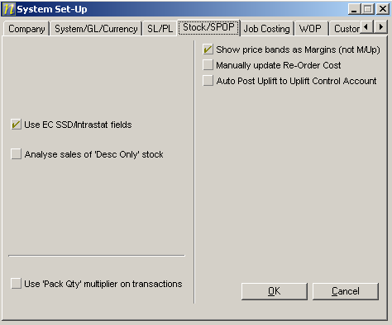

And add in stock types Group, Desc, and Delisted. With a restricted stock record view.

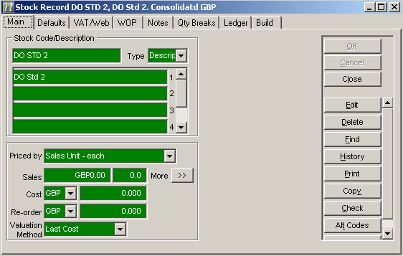

ObjectStock disabled.

Report options reduced to following sub set

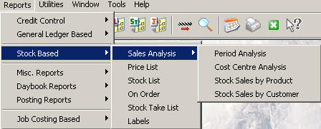

If SPOP or WOP are enabled, stock is automatically set to Full.

